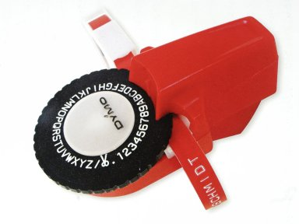**Release: nothing**

The printer design….. okay, let’s start with the picture, which is where the idea for this printer came from. This is a 1970s Dymo Labeller – it works a bit like an old daisywheel printer, except you do it by hand – you rotate the round bit, pull the trigger, and the letter appears on the tape.

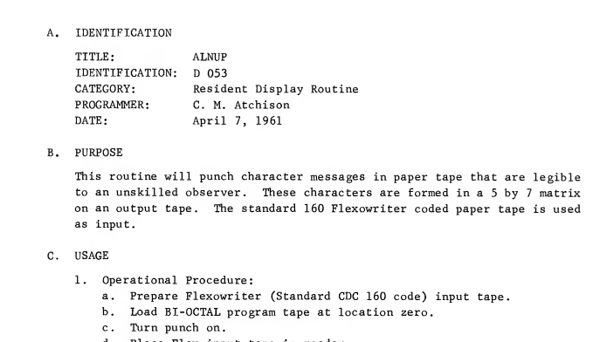The printer design is a dot matrix version of the same sort of thing. There is an array of 7 pins that are actuated by the computer (the interface is a couple of 7475s driving a relay circuit basically), and these mark the paper through a piece of inked ribbon. The 8th pin pulls the paper strip through to do the next vertical line. Without using a stepper motor (that’s going to work well ….), and so on. So you get something like the Dymo output in dot matrix form. In a long strip of paper.

When I actually looked at this I was slightly embarrassed. But then, I remembered this. This is from the CDC160 System Programmers guide, which lists the various routines provided with the minicomputer.

It’s basically exactly the same idea, except instead of using an Inkjet Ribbon it punches holes to spell letters.

So, I’m at least as smart as C.M. Atchison ☺